**Problem Set 3**

This problem set covers material from the first three classes including material from OIS Chapter 2 Section 3.2 to Chapter 4 Section 4.3. It makes use similar data to that we discussed in class. Partial credit may be given for answers that are correct in part, but not in full.

**Part I: Probability (42 pts.)**

1. It appears that the probability of a state voting for a party for president in 2020 and having a governor of the same party for governor may be related. Based on this seeming relationship, please answer the following questions. I have also provided a contingency table that summarizes the distribution of this data. (32 pts.)

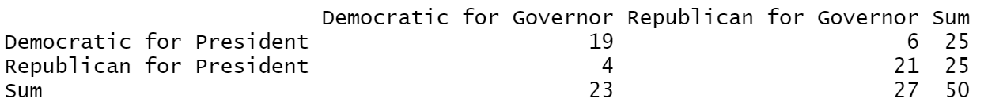

* 1. If you randomly select a state, what is the marginal probability of a state having a Democratic governor? Please show your work. (2 pts.)
  2. If you randomly select a state, what is the joint probability of the state having a Democratic governor ***and*** voting Democratic for president? Please show your work. (4 pts.)
  3. What is the conditional probability of having a Democratic governor given that a state voted Democratic for President? Please show your work. (4 pts.)
  4. Does having a Democratic governor and voting Democratic for president appear to be independent? (Hint: set the probability of voting Democratic for president as P(B).) Based on this, use the general multiplication rule to find the probability of having a Democratic governor and voting Democratic for President and discuss how this compares to the probability if they were independent. Please show your work. (6 pts.)
  5. Probability trees are a good way to organize outcomes. Please fill in this probability tree. (8 pts.)

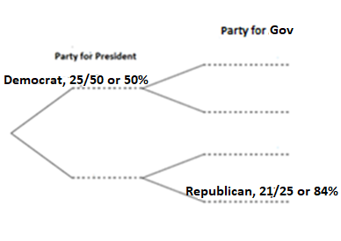

* 1. Using the probabilities you filled in above, please calculate the joint probabilities that apply to the scenarios related to each secondary branch. (Note: you can either fill them in above to the right of what you already filled in or put them here, but if you place them here, please note which secondary branch scenario they apply to below.) Please show your work. (8 pts.)

1. In class, we also discussed whether a state is part of the “Blue Wall.” 18 states are part of the “Blue Wall.” (10 pts.)
   1. The probability of having a Democratic governor given that a state is in the Blue Wall is 83.33%. (15/18 states). What is the probability of a state being in the Blue Wall given that it has a Democratic governor? (5 pts.)
   2. In 2020, all 18 Blue Wall states voted Democratic for president once again. What is the probability of a state being in the Blue Wall given that it voted Democratic for president? (5 pts.)

**Part II: Some Normal (or Non-Normal) Questions about Distributions (26 pts.)**

This section makes use of data from the 2020 Election at the state level as compiled by the [Cook Political Report](https://cookpolitical.com/2020-national-popular-vote-tracker).

1. Below is a histogram of the percentage of the vote received by Joe Biden at the state level in 2020 (bin width= 2 percentage point) and a Q-Q plot of the distribution of the data. (26 pts.)

|  |  |
| --- | --- |
|  |  |

1. Does this data look like it follows a normal distribution? Discussing both plots, what evidence is there that the data follows a normal distribution and what evidence is there that it is not distributed normally? (8 pts.)
2. Among the 50 states, the mean Biden two-party percentage is 49.70 and the standard deviation is 12.31. Biden received 54.67% of the two-party percentage in Maine. What is Maine’s z-score? What is its percentile for Democratic two-party vote? Please show your work or explain how you got the value. (6 pts.)
3. Maine allocates its electoral votes by congressional district. In Maine’s 1st District, Biden received 61.89% of the two-party vote, while in Maine’s 2nd District he received 46.17%. What is the z-score and percentile for each of these congressional districts? (You can use the same standard deviation as above for the purposes of this problem.) Please show your work or explain how you got the value (in the case of the percentile). (12 pts.)

**Part III: Don’t Rain on my Convention (12 pts.)**

1. In his new autobiography *A Promised Land*, former President Barack Obama writes about the decision to hold his 2008 convention speech outside and the worry it would rain. Obama details how campaign manager David Plouffe pulled one hundred years of weather data and it only rained once on August 28th at 8 pm in that period (p. 165). Taking this data as representative of the probability it would rain, please answer the following questions.
   1. Imagine ten speeches were held at 8 pm on August 28th in Denver. What is the probability that it would rain on exactly one of them? (6 pts.).
   2. What is the probability it would rain on none of them? (6 pts.)
2. A pollster decides to conduct a poll of North Carolina registered voters. According to the *Pew Research Center*, the response rate in polls has fallen to about 5%, so the pollster will have to make 20 times as many calls as she wants responses. This pollster is interested in the probability that a voter named Jacob Smith will be included in the poll and would like you to calculate the probability that **exactly one call** will be made to a Jacob Smith and that **at least one call** will be made to a Jacob Smith. The pollster wants the survey to have a sample size of 1,500 registered voters. Please show all relevant work; you may use R to check your answer, but you should show the steps you take to get your answer. (20 pts., 10 pts. each).

Some relevant information for this question:

* Here, we are looking at the number of calls that would need to be made to get 1,500 responses, not the number of responses. (Although you would need to use the number of responses to calculate the number of calls that would need to be made.)
* According to data from the North Carolina Board of Elections (as of the end of 2020), there are 7,379,363 registered voters in North Carolina and 198 of them are named Jacob Smith.
* Hint: First calculate the probability of a random draw of North Carolina registered voters including a Jacob Smith.